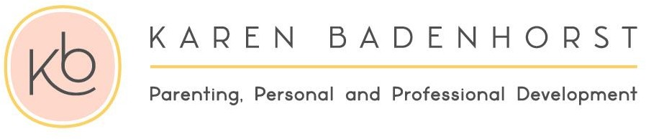
Registration Form
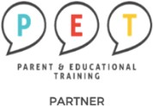

PERSONAL DETAILS
Name: Birthdate:
Tel: |  | E-mail:
Physical Address:
Suburb: |  | Study material in Afrikaans or English:
Children’s Names: |  | Ages:
Where did you hear about the PET Course?:
Your child’s School name: _
Investment in all your relationships
24 Hours Program  20 Hours Online | R 3 200 per person  R 6 000 for both parents  (Including workbook and certificate. We recommend strongly that you order the PET handbook online for R 450)
(Please select) ADDED VALUE
You can repeat this course for free any time in the future!

I am a registered service provider so you can submit my account to your medical aid provider and they will reimburse you in accordance with the rules of your medical aid plan for therapeutic services.

R 290 x 12 months
Down payment options that will suit your budget. Please pay on or before last day of the month. |  |  | R 1 600 x 2 months  R 3 000 x 2 for both parents

BANKING DETAILS
Cheque: | K Badenhorst |  | Branch: |  | 163 145
Bank: | Nedbank |  | Acc nr: |  | 163 112 8302
Ref: | Name and Surname |  | Notification: |  | 0832659388
(Please select) DATES / TIMES / VENUES
English/  Afrikaans | Wednesday  Mornings  9:00 – 12:00 | 17 April - 12 June 2024 |  | Protea Valley Church  Van Riebeeckshof  Tigervalley Clinic  Pasita street  Rosenpark
English/  Afrikaans | Tuesday  Evenings  18:00 - 20:00 | 16 April - 4 June 2024
English/  Afrikaans | Monday  Evenings  Online  19:00 - 21:30 | 15 April - 3 June
